AIAC Lab Test- 3
SET:1
Roll:2403a52222
SET 1
Q1. (Data Structures)
Using AI assistance, write a Python program to implement a Stack using a list.
Perform the following operations:
- Push 5 elements
- Pop 2 elements
- Display the remaining stack
Explain how AI helped generate or optimize your structure.
Prompt: Can you help me write a Python program that implements a stack using a list? I want to push 5 elements, pop 2, and then display the remaining stack. Also, explain how AI helped improve the code structure."

Code & Output:
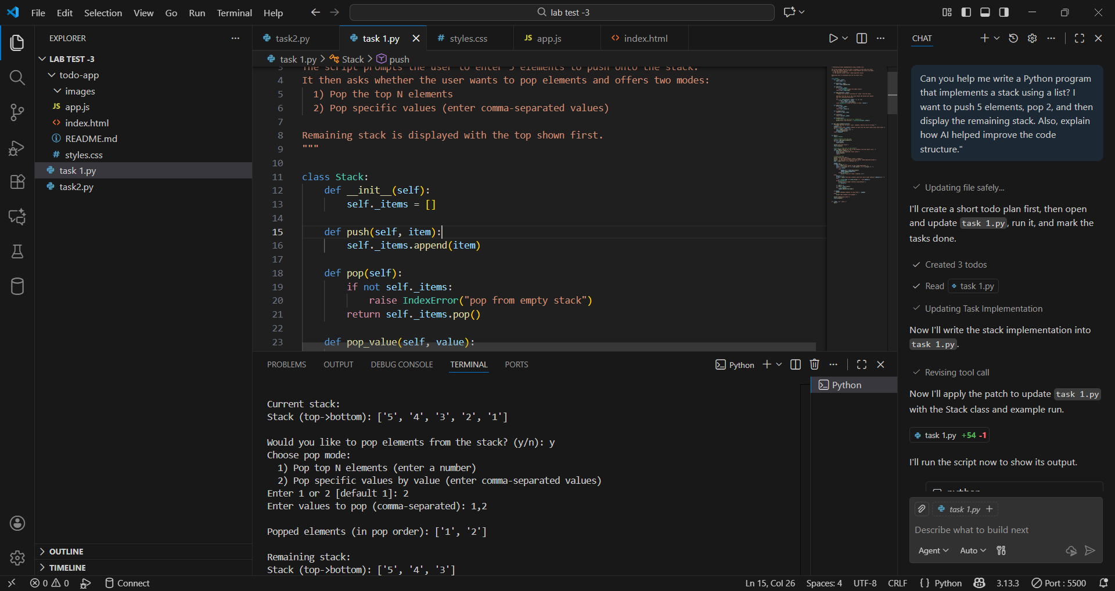
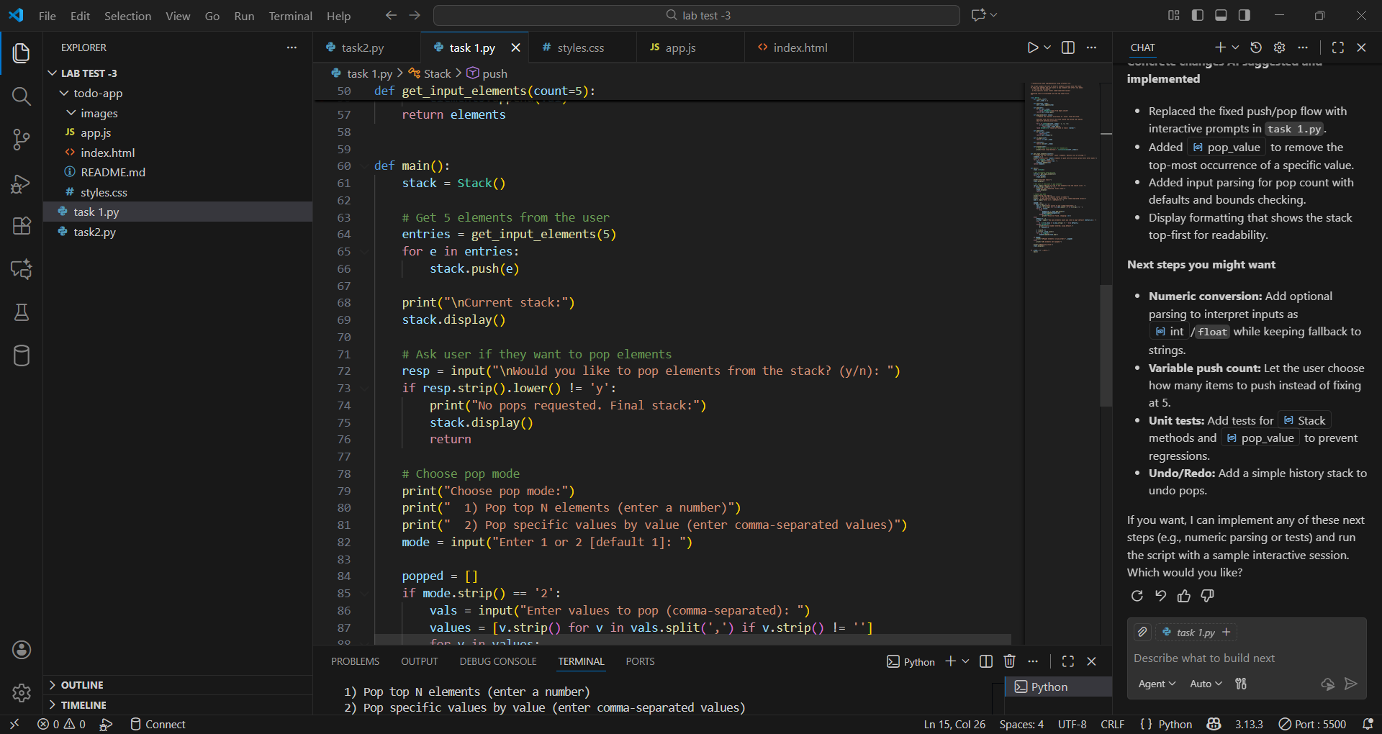
Explaination:
AI Improvements

Modularity: Introduced a Stack class and helper functions (pop_value, get_input_elements) so behavior is encapsulated and easy to reason about in task 1.py.
User Interaction: Replaced hard-coded pushes/pops with clear prompts (enter 5 elements, choose pop mode). This makes the script flexible and user-friendly.
Robustness: Added error checks and graceful fallbacks (empty-stack checks, ValueError when a value isn't found, validated numeric input for the number of pops).
Clarity & Maintainability: Added a descriptive module docstring, clear function names (push, pop, pop_value, display), and concise output messages so future readers quickly understand intent.
Single-Responsibility Functions: Split logic into small functions (input collection, popping modes, rendering) which simplifies testing and extension.
Extensibility: The data/model (plain list) and structure make it straightforward to add features later (numeric parsing, variable push count, undo, unit tests).
Concrete changes AI suggested and implemented

Replaced the fixed push/pop flow with interactive prompts in task 1.py.
Added pop_value to remove the top-most occurrence of a specific value.
Added input parsing for pop count with defaults and bounds checking.
Display formatting that shows the stack top-first for readability.
Next steps you might want

Numeric conversion: Add optional parsing to interpret inputs as int/float while keeping fallback to strings.
Variable push count: Let the user choose how many items to push instead of fixing at 5.
Unit tests: Add tests for Stack methods and pop_value to prevent regressions.
Undo/Redo: Add a simple history stack to undo pops.
Q2. (Web Frontend)
With AI tools, develop an interactive To-Do List App using HTML, CSS, and JavaScript.
Include features:
- Add task
- Delete task
- Mark as completed
Prompt: develop an interactive To-Do List App using HTML, CSS, and JavaScript.
Include features:Add task, Delete task,Mark as completed
Code & Output:
1.HTML
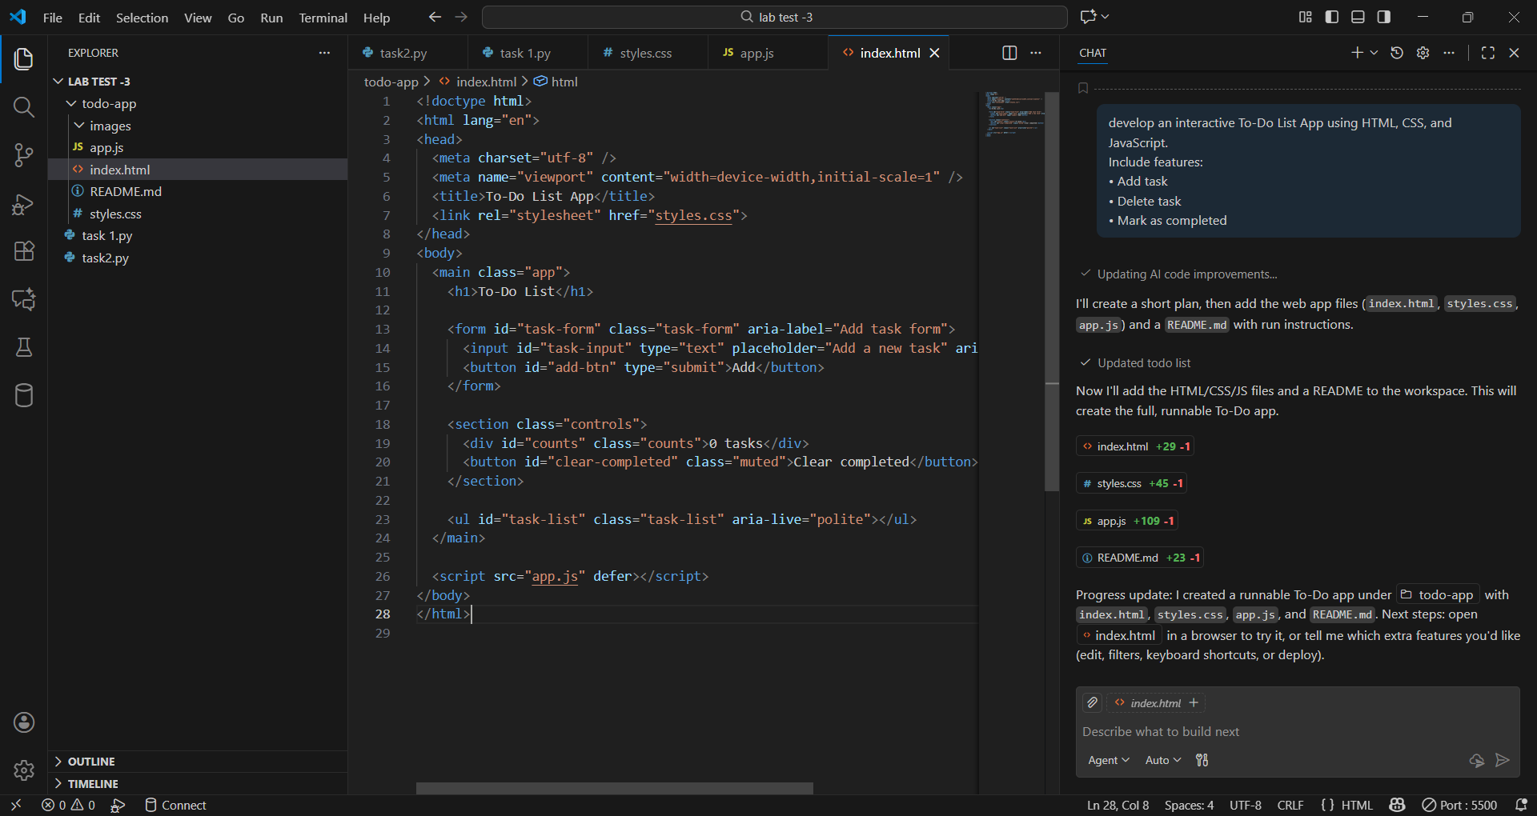

2.CSS
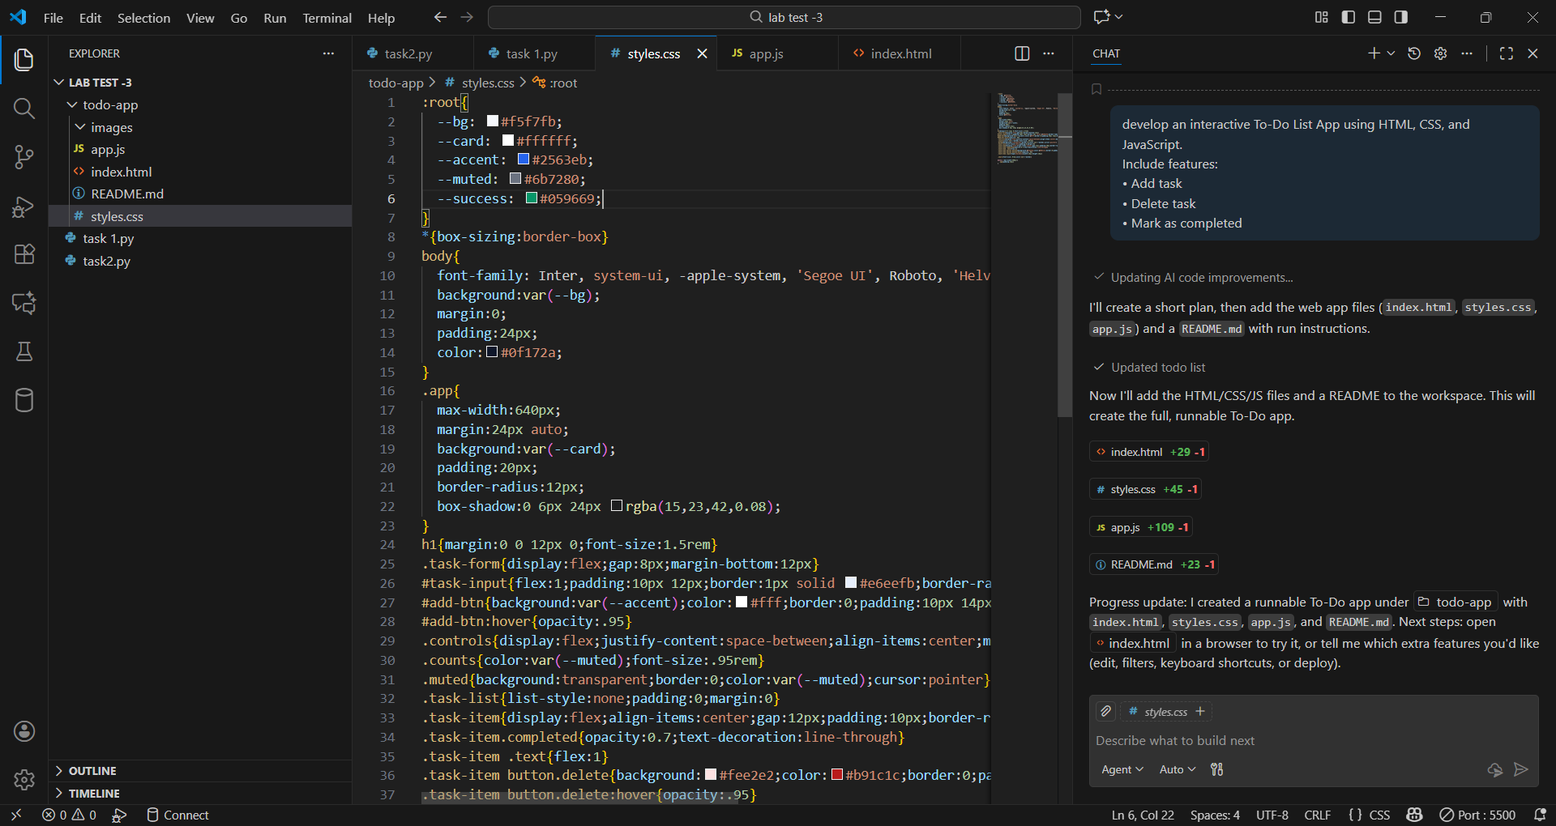
3.Java Script
